Федеральное государственное образовательное бюджетное

учреждение высшего образования

**«Финансовый университет при Правительстве Российской Федерации»**

**(Финансовый университет)**

Колледж информатики и программирования

**ОТЧЕТ О ВЫПОЛНЕНИИ ЗАДАНИЯ № 3**

**Тема: «Создание таблицы в MS Word»**

Студент: Бек-Назарова А. Н.

Группа: 3ПКС-420

Преподаватель: Сибирев И. В.

Дата: 24.11.2022

**Цель работы**: необходимо разработать программу, которая при нажатии на кнопку создает таблицу в MS Word.

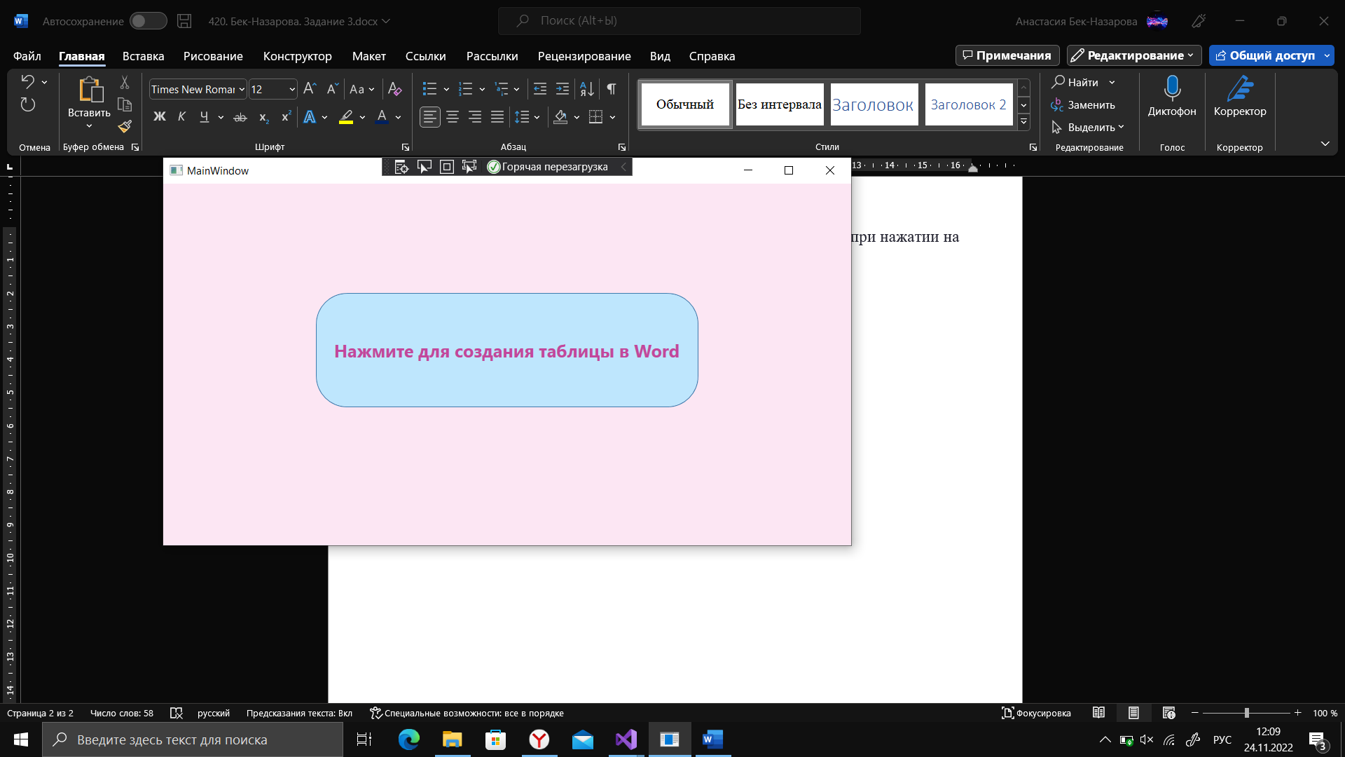

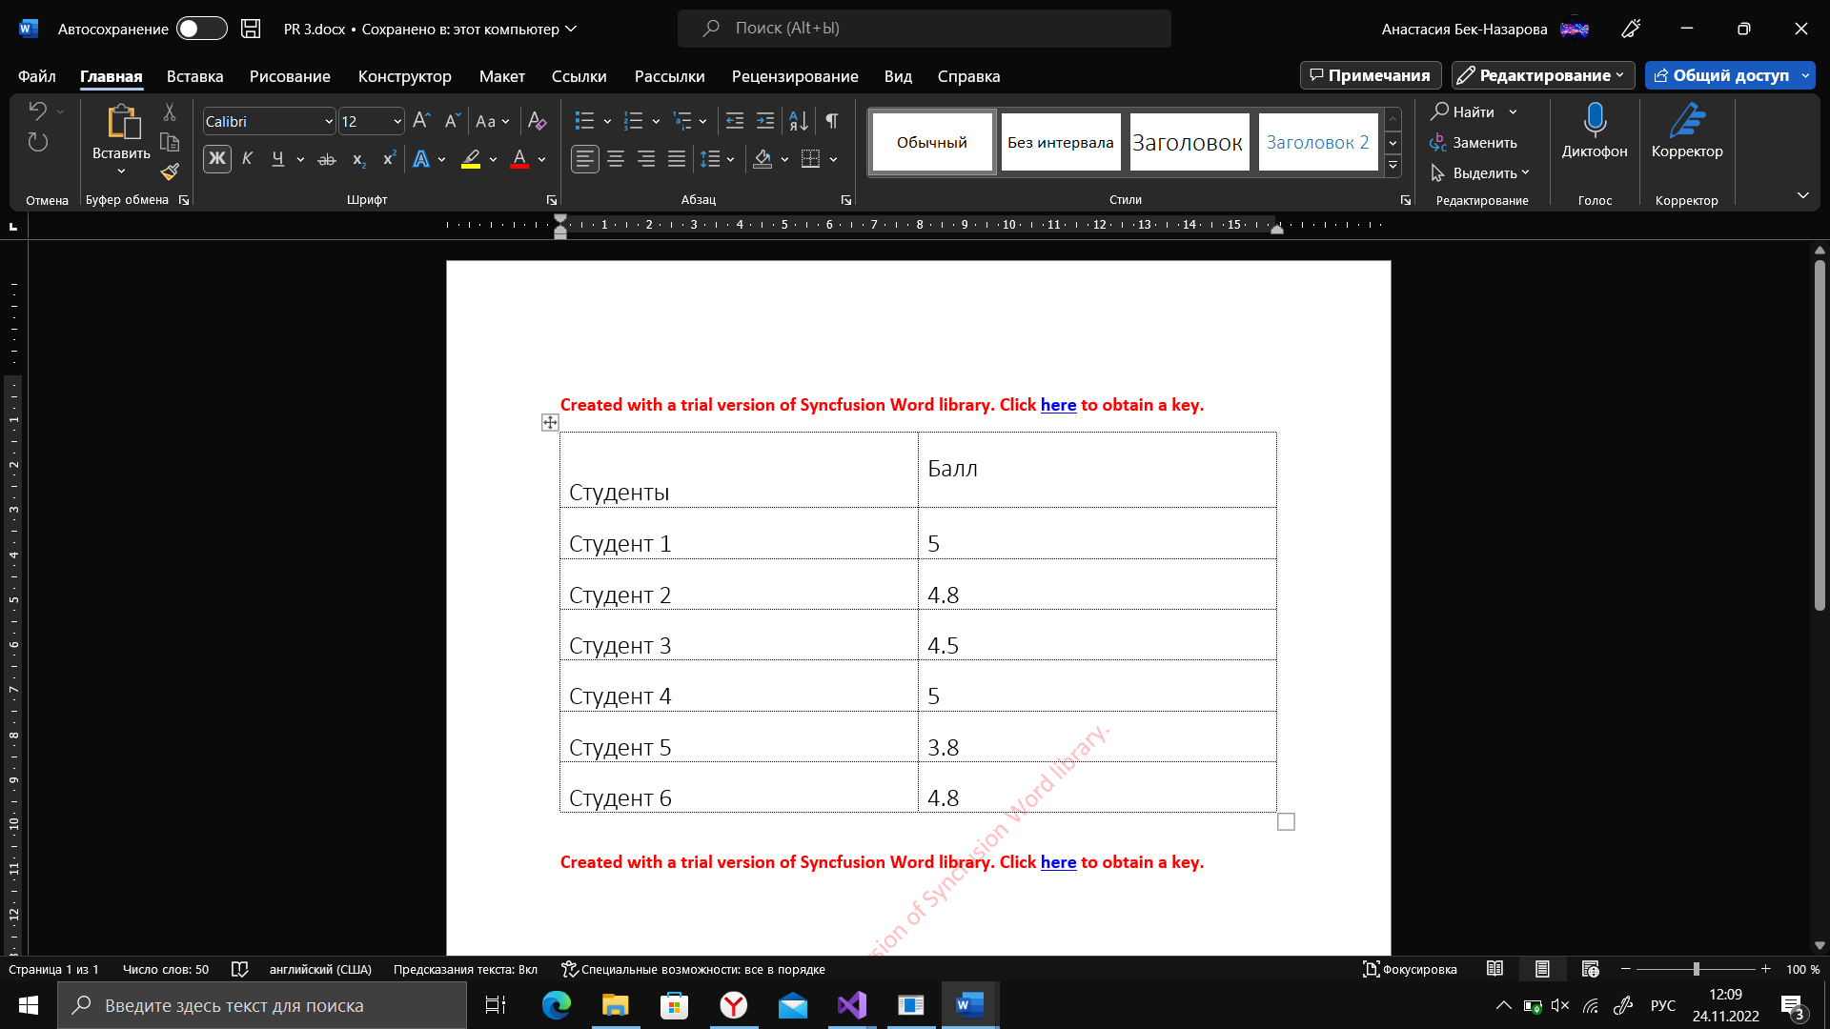

using Syncfusion.DocIO;

using Syncfusion.DocIO.DLS;

using System;

using System.ComponentModel;

using System.Diagnostics;

using System.Drawing;

using System.Windows;

namespace zadanie3

{

/// <summary>

/// Логика взаимодействия для MainWindow.xaml

/// </summary>

public partial class MainWindow : Window

{

public MainWindow()

{

}

private void Button_Click(object sender, RoutedEventArgs e)

{// Creating a new document.

WordDocument document = new WordDocument();

//Adding a new section to the document.

WSection section = document.AddSection() as WSection;

//Set Margin of the section

section.PageSetup.Margins.All = 72;

//Set page size of the section

//Create Paragraph styles

WParagraphStyle style = document.AddParagraphStyle("Normal") as WParagraphStyle;

style.CharacterFormat.FontName = "Calibri";

style.CharacterFormat.FontSize = 11f;

style.ParagraphFormat.BeforeSpacing = 0;

style.ParagraphFormat.AfterSpacing = 8;

style.ParagraphFormat.LineSpacing = 13.8f;

style = document.AddParagraphStyle("Heading 1") as WParagraphStyle;

style.ApplyBaseStyle("Normal");

style.CharacterFormat.FontName = "Calibri Light";

style.CharacterFormat.FontSize = 16f;

style.ParagraphFormat.BeforeSpacing = 12;

style.ParagraphFormat.AfterSpacing = 0;

style.ParagraphFormat.Keep = true;

style.ParagraphFormat.KeepFollow = true;

style.ParagraphFormat.OutlineLevel = OutlineLevel.Level1;

IWParagraph paragraph = section.HeadersFooters.Header.AddParagraph();

// Gets the image stream.

//Appends table.

IWTable table = section.AddTable();

table.ResetCells(7, 2);

table.TableFormat.Borders.BorderType = BorderStyle.Dot;

table.TableFormat.IsAutoResized = true;

//Appends paragraph.

paragraph = table[0, 0].AddParagraph();

paragraph.ParagraphFormat.AfterSpacing = 0;

//Appends picture to the paragraph.

paragraph = table[0, 0].AddParagraph();

paragraph.ApplyStyle("Heading 1");

paragraph.ParagraphFormat.AfterSpacing = 0;

paragraph.ParagraphFormat.LineSpacing = 12f;

paragraph.AppendText("Студенты");

//Appends paragraph.

paragraph = table[0, 1].AddParagraph();

paragraph.ApplyStyle("Heading 1");

paragraph.ParagraphFormat.AfterSpacing = 0;

paragraph.ParagraphFormat.LineSpacing = 12f;

paragraph.AppendText("Балл");

paragraph = table[1, 0].AddParagraph();

paragraph.ApplyStyle("Heading 1");

paragraph.ParagraphFormat.AfterSpacing = 0;

paragraph.ParagraphFormat.LineSpacing = 12f;

paragraph.AppendText("Студент 1");

//Appends paragraph.

paragraph = table[1, 1].AddParagraph();

paragraph.ApplyStyle("Heading 1");

paragraph.ParagraphFormat.AfterSpacing = 0;

paragraph.ParagraphFormat.LineSpacing = 12f;

paragraph.AppendText("5");

paragraph = table[2, 0].AddParagraph();

paragraph.ApplyStyle("Heading 1");

paragraph.ParagraphFormat.AfterSpacing = 0;

paragraph.ParagraphFormat.LineSpacing = 12f;

paragraph.AppendText("Студент 2");

//Appends paragraph.

paragraph = table[2, 1].AddParagraph();

paragraph.ApplyStyle("Heading 1");

paragraph.ParagraphFormat.AfterSpacing = 0;

paragraph.ParagraphFormat.LineSpacing = 12f;

paragraph.AppendText("4.8");

paragraph = table[3, 0].AddParagraph();

paragraph.ApplyStyle("Heading 1");

paragraph.ParagraphFormat.AfterSpacing = 0;

paragraph.ParagraphFormat.LineSpacing = 12f;

paragraph.AppendText("Студент 3");

//Appends paragraph.

paragraph = table[3, 1].AddParagraph();

paragraph.ApplyStyle("Heading 1");

paragraph.ParagraphFormat.AfterSpacing = 0;

paragraph.ParagraphFormat.LineSpacing = 12f;

paragraph.AppendText("4.5");

paragraph = table[4, 0].AddParagraph();

paragraph.ApplyStyle("Heading 1");

paragraph.ParagraphFormat.AfterSpacing = 0;

paragraph.ParagraphFormat.LineSpacing = 12f;

paragraph.AppendText("Студент 4");

//Appends paragraph.

paragraph = table[4, 1].AddParagraph();

paragraph.ApplyStyle("Heading 1");

paragraph.ParagraphFormat.AfterSpacing = 0;

paragraph.ParagraphFormat.LineSpacing = 12f;

paragraph.AppendText("5");

paragraph = table[5, 0].AddParagraph();

paragraph.ApplyStyle("Heading 1");

paragraph.ParagraphFormat.AfterSpacing = 0;

paragraph.ParagraphFormat.LineSpacing = 12f;

paragraph.AppendText("Студент 5");

//Appends paragraph.

paragraph = table[5, 1].AddParagraph();

paragraph.ApplyStyle("Heading 1");

paragraph.ParagraphFormat.AfterSpacing = 0;

paragraph.ParagraphFormat.LineSpacing = 12f;

paragraph.AppendText("3.8");

paragraph = table[6, 0].AddParagraph();

paragraph.ApplyStyle("Heading 1");

paragraph.ParagraphFormat.AfterSpacing = 0;

paragraph.ParagraphFormat.LineSpacing = 12f;

paragraph.AppendText("Студент 6");

//Appends paragraph.

paragraph = table[6, 1].AddParagraph();

paragraph.ApplyStyle("Heading 1");

paragraph.ParagraphFormat.AfterSpacing = 0;

paragraph.ParagraphFormat.LineSpacing = 12f;

paragraph.AppendText("4.8");

//Appends paragraph.

section.AddParagraph();

//Saves the Word document

document.Save("C:\\PR 3.docx");

Process wordProcess = new Process();

wordProcess.StartInfo.FileName = "C:\\PR 3.docx";

wordProcess.StartInfo.UseShellExecute = true;

wordProcess.Start();

}

}

}

**Вывод**: разработана программа, которая при нажатии на кнопку создает таблицу в MS Word.